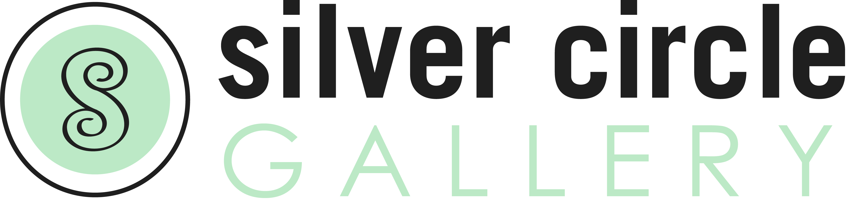

COLLABORATIVE EXHIBIT SUBMISSION FORM (please fill out and email)

Exhibit Title: Trashion Show
Dates: April 15 – May 27, 2018
Reception: April 15, 2018 time TBD

Name:_________________________________________________________________________
Email:_________________________________________________________________________
Address:_______________________________________________________________________
Phone number:_________________________________ Website:_______________________________________________

Title | Size | Medium | Price | Notes
1
2
3

